1. Install VirtualBox 5.1.4 for windows from below URL.

URL: <http://download.virtualbox.org/virtualbox/5.1.14/VirtualBox-5.1.14-112924-Win.exe>

1. Install Vagrant 1.8.5 from below URL.

URL

1. Also make sure you have enabled Virtual Machine extension in your BIOS settings. This can be verified only in the BIOS screen during startup of your laptop.
2. For windows 8 and 10 users make sure you disable the firewall or anti-virus as sometimes the host machine might not be reachable to guest VM’s
3. Create a folder ‘vagrantvm’

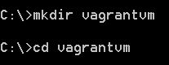

1. Run the below command. Make sure you have run the command prompt with Administrator.

vagrant init ubuntu/trusty64

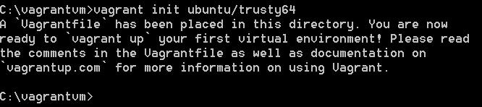

1. The above command creates a Vagrant file which defines the configuration set of your VM.
2. Open it with text editor and walk through it.
3. Go to Virtualbox and choose File -> Preferences -> Network -> Host-only Network option.

Click on  icon to create a new host-only network.

1. Make sure the Adapter and DHCP Server tab settings as below

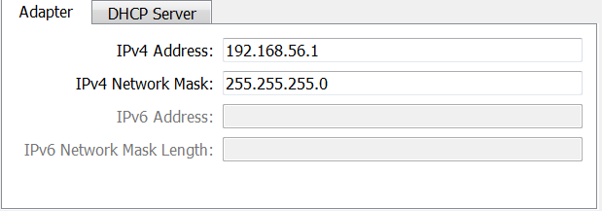

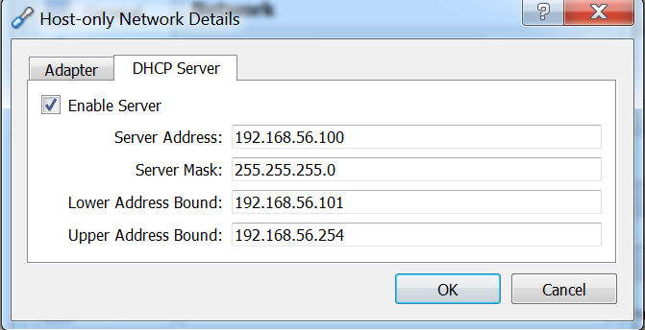

1. Make sure you understand each of the fields.
2. Click on OK twice and come back to the main Virtual Box screen
3. Open the Vagrantfile in text editor and remove the comment for the line ‘config.vm.network’ and modify as shown below

config.vm.network "private_network", ip: "192.168.56.109", name: "VirtualBox Host-Only Ethernet Adapter"

Make sure the name of the host only adapter matches which you have specified in the VirtualBox settings.

Make sure the IP specified is unique and make a note of it. This will be the IP assigned to the VM.

1. Run the below Vagrant command in the ‘C:\vagrantvm’. This will take some time as it will download the Vagrant box from central site

vagrant up --provider virtualbox

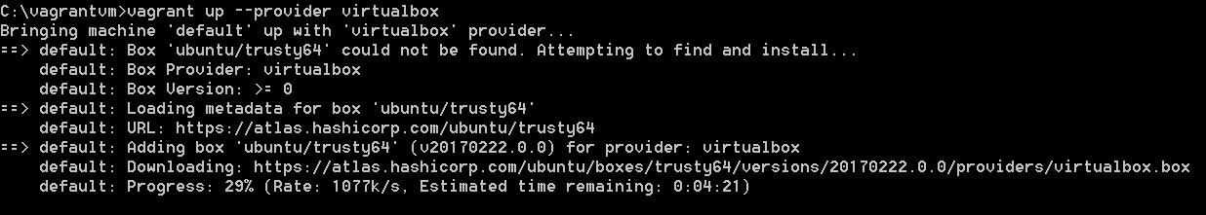

1. The command ends with something as below.

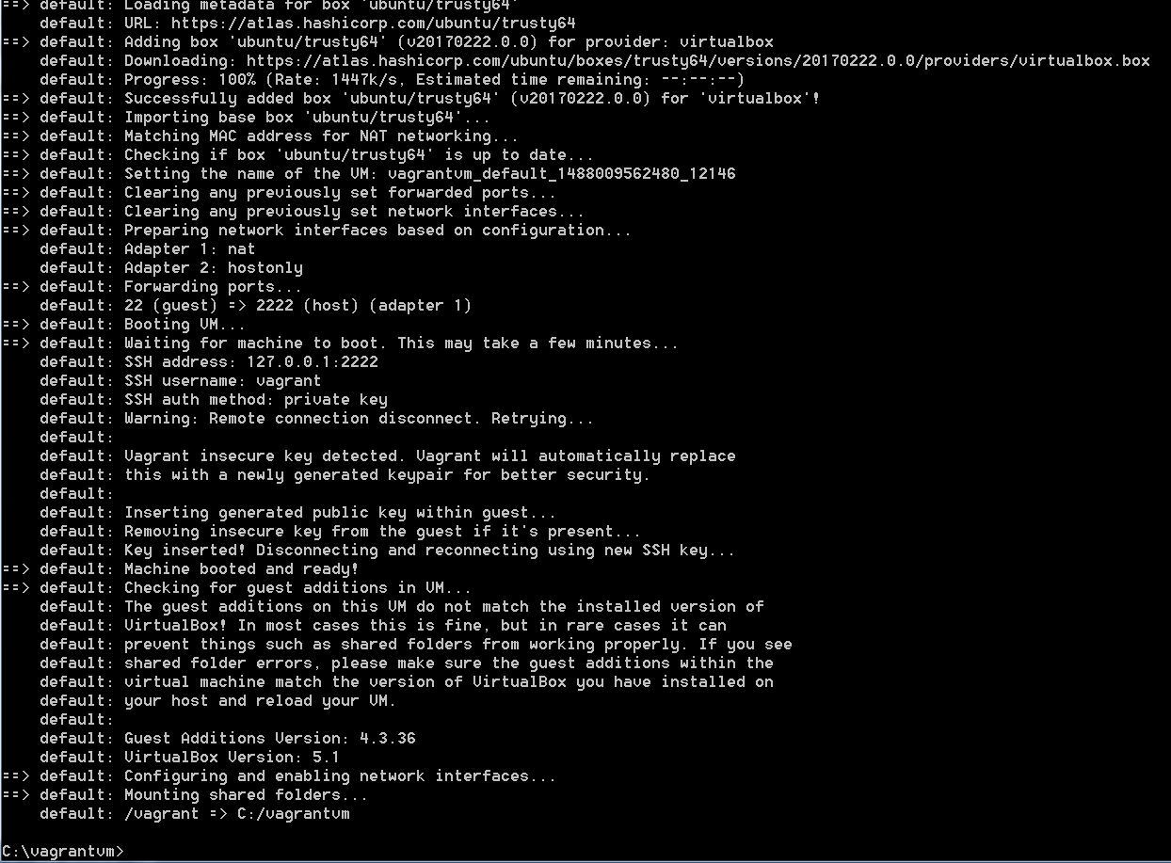

1. The machine is ready if you do not get any errors.
2. Download Putty from the below URL

URL: <http://www.putty.org/>

1. Open putty and enter the IP mentioned in Vagrantfile.

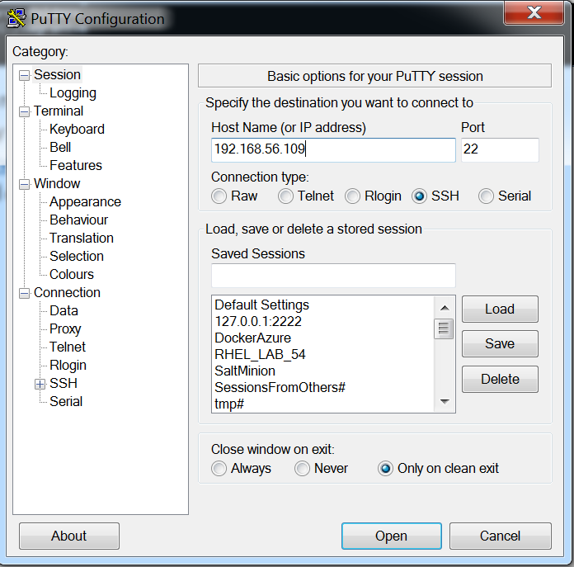

1. Click on Open and you should be able to login to the VM using below credentials.

User: vagrant

Pwd: vagrant

1. Make sure from within the VM you should be able to ping to the host machine.
2. VM is ready and you can install packages and configure.

***Don’t perform below actions***

**Proxy setting for INTERNET DOWNLOAD**

Go to /etc/apt -> create a apt.conf file -> paste *Acquire::http::Proxy "http://web-proxy.houston.hpecorp.net:8080";*  -> save the file.